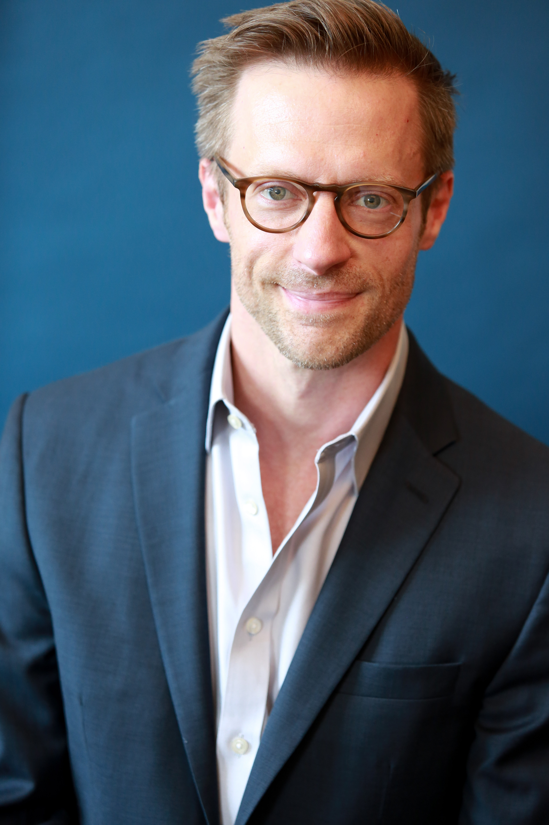
Jon Barker AEA/SAG-AFTRA

Contact: barkerjon@mac.com 917.853.1599 www.barkerjon.actor

Eyes: Blue Hair: Light Brown Ht: 6’1 Wt: 175 lbs.

NY and Regional Theater
Shakespeare Theatre of NJ The Winter’s Tale Leontes dir. Bonnie J. Monte
Shakespeare in Love Will dir. Bonnie J. Monte
The Complete Works of William Shakespeare Jess dir. Jeffrey M. Bender
Exit the King Guard dir. Bonnie J. Monte
Colorado Theatreworks The Girl of the Golden West Sheriff Jack Rance dir. Murray Ross
Shakespeare Theatre of NJ The Merry Wives of Windsor Doctor Caius dir. Bonnie J. Monte
NJ Symphony Orchestra Romeo and Juliet Mercutio dir. Bonnie J. Monte
Shakespeare Theatre of NJ The Alchemist Face dir. Bonnie J. Monte
The Tempest Caliban dir. Bonnie J. Monte
Colorado Theatreworks Venus In Fur Thomas dir. Murray Ross
Shakespeare Theatre of NJ Pericles Pericles dir. Brian B. Crowe
Tovarich Prince Mikhail dir. Bonnie Monte
Colorado Theatreworks The Wild Duck Gregers dir. Murray Ross
Strangedog Theatre Co. Omnivores Cole dir. Artem Yatsunov
NJ Symphony Orchestra The Tempest Caliban dir. Bonnie J. Monte
Shakespeare Theatre of NJ Trelawny of the Wells Ferdinand Gadd dir. Bonnie J. Monte
Henry IV Part One Hotspur dir. Joe Discher
Luna Stage The Dangers of Electric Lighting Nikola Tesla dir. John Henry Davis
Shakespeare Theatre of NJ Othello w/Robert Cuccioli Cassio dir. Bonnie J. Monte The Misanthrope Philinte dir. Bonnie J. Monte
All’s Well That Ends Well w/Tamara Tunie Dumaine dir. Stephen Brown-Fried
The Taming of the Shrew Tranio dir. Bonnie J. Monte
Twelfth Night Fabian dir. Bonnie J. Monte
The School for Wives Horace dir. Brian B. Crowe
The Winter’s Tale Cleomenes dir. Brian B. Crowe
Romeo and Juliet Paris dir. David Kennedy

Film & TV
Discovery ID Channel Scorned: Love Kills Ep. 115 Larry Ford dir. Remy Weber
Strangedog Films Pluto Greg dir. Ari Frenkel

Tour
ShakespeareLIVE! A Midsummer Night’s Dream Lysander/Flute dir. Stephen Brown-Fried
Macbeth Porter/Seyton dir. Stephen Brown-Fried
Nevermore Edgar dir. Brian B. Crowe

Training Special Skills
On-Camera Technique Bob Krakower Carpentry: Professional (18 years)
Linklater Technique Liz Eckert Music: Intermediate Guitar
BFA Acting Montclair State University Dialects: Irish, British RP, Southern
Acting Suzanne Trauth, Susan Kerner Combat: Armed and Unarmed
Shakespeare Jorge Cachiero, Geoffrey Owens
Voice/Speech/Dialects Diane Zaremba, Lenore Harris
Movement/Viewpoints Ruth Clark, Christian Ely
Stage Combat Rick Sordelet, Joseph Daly

